



[Organization name (organization name)]

Commercial Proposal
Integrated Safety at Every ElevationTM
Presented to
[Person full name (person name)]
[Person job title (person job_title)]
[Long today's date (datetime today)]

Contact Details

Name | [Deal owner (deal user_id)]
Phone | US +1 (844) 784-9836 | UK
E-mail | [Deal owner email (deal user_email)]

Copyright Notice
All rights reserved. No part of this publication may be reproduced, distributed, or transmitted in any form or by any means, including photocopying, recording, or other electronic or mechanical methods, without the prior written permission of TrustFlight Ltd.

© 2026 by TrustFlight Ltd.

Table of contents

Company Overview and Strategic Vision 6
TrustFlight Group 6
Company Vision and Strategic Direction 6
Core Business and Key Capabilities 6
Regulatory Expertise 7
Financial Strength 7
Leadership Team 7
Product Capabilities 9
Tech Log 9
Centrik 5 9
MEL Manager 9
Smart Documents 10
Smart Regulations 10
Integration Ecosystem 10
Technical Services 11
Continuing Airworthiness Management Organization (CAMO) 11
AOC Services 11
Manual Revision Service and Operations Consulting 11
Fleet Asset Management 11
Postholder Service 11
Centrik Training 11
Centrik Ops Support 11
Part-IS Solution 11
Implementation Experience 12
Tech Log Technical Overview 13
Functional Description 13
Tech Log Overview 13
Tech Log Capabilities Matrix 14
Tech Log Product Roadmap 15
Centrik 5 Technical Overview 16
Functional Description 16
Centrik 5 Overview 16
Centrik 5 Capabilities Matrix 17
Artificial Intelligence 17
Centrik 5 Product Roadmap 18
Integrations 19
Technical Description 19
SLAs 19
Training 20
Data Migration 20
Smart Documents Technical Overview 21
Functional Description 21
Smart Documents Overview 21
Smart Documents Capabilities Matrix 22
Smart Documents Product Roadmap 22
Smart Regulations Technical Overview 23
Functional Description 23
Smart Regulations Overview 23
Smart Regulations Capabilities Matrix 23
Smart Regulations Product Roadmap 24
Implementation Schedule 25
Team Structure and Cadence 25
Dedicated Project Management 25
Frequency and Method of Communication 25
Implementation Experience 25
Proposed Schedule 26
Commercial Proposal 28
Cost and Pricing Model 28
Terms and Conditions 29
References 30
ISO 9001 Certification 31
ISO 27001 Certification 32

[Organization name (organization name)]
[Organization address (organization address)]
[Short today's date (datetime today_short)]

Dear [Person full name (person name)],

TrustFlight is pleased to present [COMPANY] with a [PRODUCT]. Within this response, we have outlined both our solution's capabilities as well as the strength of our organization as a long-term partner to [COMPANY].
TrustFlight has a proven track record of over 750 successful, on-time digital transformation implementations across our portfolio of training and consulting, systems, and emergency response for aerospace operators worldwide. With more than 1,600 customers spanning 120+ countries, TrustFlight is fully compliant with global cybersecurity and regulatory requirements, ensuring our solution meets and exceeds [COMPANY]'s requirements.
We firmly believe we are the best possible partner for your project due to our:
[SAMPLE VALUE PROPOSITIONS, PLEASE ENSURE THEY ALIGN WITH THE RELEVANT RFP]
- User-friendly safety reporting channel: Our industry-leading UX/UI ensures all [COMPANY] staff and stakeholders can easily submit reports with ease to improve safety culture
- Automated quality management tools: Predictable, fleet-based pricing includes modules for automated audit scheduling, tracking, and corrective action follow-up, ensuring consistent and demonstrable ROI
- Integrated risk management framework: Our system enables systematic risk assessments and maintains dynamic risk registers, helping to identify, assess, and mitigate operational hazards.
- Compliance-ready reporting: Real-time regulatory alerts embedded within our operational management system generate audit-ready reports aligned with both GACA and ICAO SMS requirements, ensuring continuous compliance across jurisdictions.
- Advanced data analytics and trend monitoring: Seamless integrations with business intelligence platforms and other systems allow proactive monitoring of safety performance indicators, supporting data-driven decision making.
- Scalability and configurability: Enterprise-wide standardisation on a single system enables personnel to move between sites without manual record transfers, while high configurability ensures alignment with [COMPANY]’s unique operational requirements.
- Future-ready AI ecosystem: Beyond today’s needs, our unique AI applications deliver next-generation capabilities such as intelligent regulatory database search and predictive safety insights.
Today, over 200,000 users worldwide rely on TrustFlight's systems to manage safety, quality, and risk. We bring a combination of technical expertise, regulatory insight, integration capability, and ROI-driven innovation—all delivered through an exceptionally usable platform trusted by aviation leaders globally.
We look forward to collaborating on next steps for project execution and implementation.

Best regards,
[Deal owner (deal user_id)]
Account Executive
[Deal owner email (deal user_email)]
US +1 (844) 784-9836 | UK

Company Overview and Strategic Vision
TrustFlight Ltd. is a leading digital technology provider specializing in the aerospace and aviation sector. Headquartered in London, United Kingdom, TrustFlight delivers innovative software and technical services that enhance safety, efficiency, and operational insight across the aviation ecosystem. Today, TrustFlight supports over 1,600 customers across more than 120 countries. Our workforce of 300+ aviation professionals brings decades of hands-on experience from leading aerospace organizations, enabling us to deliver industry-leading digital transformation at scale.
Founded by commercial pilots Karl Steeves (CEO) and Dr. Richard Steeves (Chairman), TrustFlight was built on deep operational knowledge and has since evolved into a trusted global partner for airlines, regulators, airports, OEMs, MROs, business aviation, and special mission operators.

TrustFlight Group
In August 2025, TrustFlight announced the acquisition of three specialist aviation services firms which strengthen TrustFlight’s end-to-end offering by bringing together:
- Training, regulatory expertise and risk management (Baines Simmons)
- Full-spectrum emergency preparedness and incident response (Kenyon Emergency Services)
- Aviation security, quality assurance, front-line threat training and software (Redline Assured Security)
By integrating these complementary capabilities, TrustFlight is now an end-to-end safety platform that supports prevention, assurance, and recovery across the aviation sector. Through organic growth and strategic acquisitions, TrustFlight has rapidly expanded its capabilities to meet the evolving needs of modern aviation.

 | 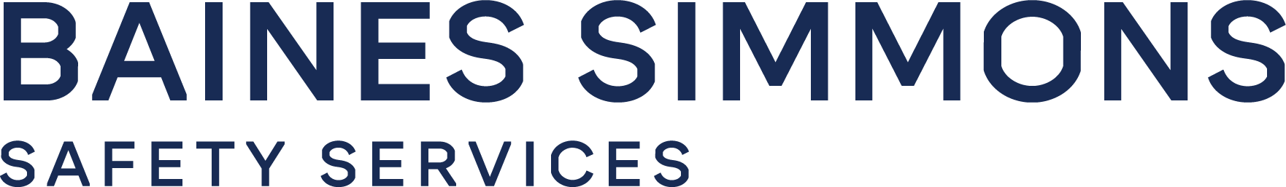 |  | 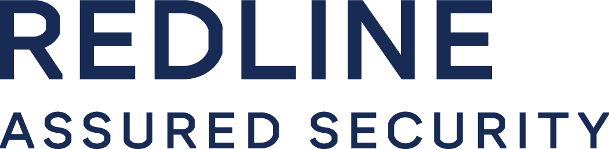

Company Vision and Strategic Direction
TrustFlight’s vision is to become the aviation industry’s most trusted and comprehensive provider of digital workflow solutions— enabling organizations to capture, store, and share operational data to enhance safety, efficiency, and compliance.
Our team of aviation professionals includes subject matter experts in safety and quality, former regulators, commercial pilots, postholders, product managers, software developers, and continuing airworthiness professionals. This broad and specialized talent base spans all segments of aviation and underpins our ability to deliver relevant, effective solutions that solve real-world challenges.
At the core of our innovation is a deep collaboration between our in-house software development teams and domain experts, ensuring that each product is grounded in operational reality and purpose-built for aviation’s evolving needs.
Strategically, TrustFlight is focused on:
- Eliminating operational silos through interoperable systems and harmonized data flows
- Real-time alerting and analytics to support proactive decision-making across departments
- Open architecture and API-driven design, ensuring seamless integration across flight operations, maintenance, compliance, and safety functions
- Expanding market coverage and solution capability through strategic mergers and acquisitions, while maintaining focus on customer value and operational excellence
As we grow, TrustFlight remains committed to developing the most advanced, intuitive, and effective digital solutions for the global aviation industry to achieve safer, smarter, and more connected operations.

Core Business and Key Capabilities
TrustFlight delivers integrated safety software and services purpose-built for the aerospace and aviation industry. Our core business is centered on enabling aviation organizations to replace legacy and paper-based workflows with intelligent, connected systems that improve accuracy, efficiency, and compliance across all operational areas.
By offering real-time access to both live and historical operational data, TrustFlight empowers teams to make timely, data-driven decisions that enhance safety and performance. Our solutions strengthen internal communication, streamline change management, and break down silos between departments—particularly between maintenance, flight operations, quality, safety, and training teams. This connected ecosystem fosters a more collaborative, transparent working environment, enabling proactive management of issues before they escalate.
A key capability of our platform is the automation of routine and compliance-critical processes. Whether managing safety reports, maintenance deferrals, document updates, or audit trails, our systems reduce the administrative burden while ensuring consistency and regulatory alignment. By embedding compliance into daily workflows and incorporating real-time regulatory alerts, TrustFlight helps organizations maintain continuous oversight without adding friction to their operations.

Regulatory Expertise
TrustFlight strategically employs former aviation regulators across its business to ensure consistent, reliable working relationships with regulatory authorities to achieve compliance and approval for digital transformation initiatives. Additionally, over 15 regulatory agencies worldwide leverage our systems to oversee operators within their purviews.

Financial Strength
Backed by strong private financial support that is not challenged by economic volatility, TrustFlight is an active player in the aviation sector and has grown through acquisitions of leading teams from around the world to evolve and remain competitive in the marketplace. This means there is no risk of TrustFlight becoming acquired or absorbed within another entity to ensure continuity of our service commitment to our customers—an important distinction in an industry known for strategic mergers and acquisitions.

Leadership Team
TrustFlight’s leadership structure is built around agile, customer-centric governance, ensuring rapid and effective decision-making throughout the lifecycle of every engagement. Our functional teams operate with autonomy and accountability, while complex or cross-functional decisions benefit from direct involvement by the company’s directors, including Karl Steeves (CEO) and Dr. Richard Steeves (Chairman). This ensures timely allocation of resources, operational alignment, and executive oversight on all engineering, product, and implementation activities.
Key functional departments include:
- Executive Leadership
- Technology and Engineering
- Product & Project Management
- Marketing and Sales
- Technical Services (AOC, CAMO, Publishing, Fleet Management)
- Cybersecurity, Infrastructure & IT
- Implementation & Support
- Finance and Administration
- Human Resources

Dr. Richard Steeves, Chairman
Dr. Steeves is an experienced business leader with a strong track record in scaling companies and executing strategic growth. He co-founded TrustFlight in 2017 and has served as Chairman since inception, guiding its expansion as a global provider of digital aviation solutions. Prior to TrustFlight, he founded Synergy Health plc, where he served as CEO for over two decades—growing the company into a FTSE 250-listed organization through international expansion and multiple acquisitions. He has also held governance roles in aviation, including as a non-executive director at Gama Aviation plc, and brings deep cross-sector experience across regulated industries. Dr. Steeves plays a key role in shaping TrustFlight’s strategic direction and scaling operations to meet the evolving needs of the global aviation market.
Karl Steeves, Chief Executive Officer
Mr. Steeves holds an Engineering degree from Imperial College London. He began his career developing safety-critical systems for electric vehicles before becoming a commercial pilot. In 2017, he founded TrustFlight with a vision to modernize aviation through technology. Under his leadership, TrustFlight has grown into a globally respected provider of digital workflow solutions—serving major fleet operators across North America, Europe, and Asia with tools such as the Tech Log, Centrik, MEL Manager, and Smart Regulations.
Dr. Amir Kusedghi, Chief Information Officer
Dr. Kusedghi leads TrustFlight’s technology operations, bringing deep expertise in cloud platforms, cybersecurity, and IT architecture. Prior to joining TrustFlight, he co-founded a successful cloud computing company whose products now support over half a million users. He holds a PhD in Computer Engineering and was awarded the Mitacs Postdoctoral Fellowship at the University of British Columbia for advanced work in telecommunications. He regularly consults for global aerospace organizations on digital strategy.
Ryan O’Connell, VP of Customer Success
Ryan has extensive experience building and leading customer experience teams, ensuring processes and ways of working deliver results for customers. Specialising in working with technology companies, he has also worked at leading brands such as Barclays, KPMG and BP. Ryan has directly supported customers such as British Airways and Emirates and has a passion for customer excellence.
Matt Rees, VP of Sales
Matt Rees is an experienced SaaS revenue leader with over 20 years’ success scaling high-growth technology businesses and leading global sales teams across EMEA, North America and APAC. His background spans enterprise software, digital experience and software performance testing, with a consistent focus on automating complex manual processes. Matt has guided multiple scale-ups through major growth milestones and successful equity exits. At TrustFlight, he leads global Sales across Software and Services, bringing structured execution, commercial rigour and a strong customer-value mindset to drive expansion of TrustFlight’s aviation-safety solutions.
Reuben Mann, Senior Director of Marketing
Mr. Mann serves as Senior Director of Marketing and a member of the executive leadership team. He is responsible for brand positioning, growth strategy, and commercial enablement. Prior to joining TrustFlight, he founded and led a Marketing Centre of Excellence for a large aerospace group, supporting commercial teams across sectors including advanced air mobility, public safety, offshore energy, and defense. He holds a Bachelor of Science in Biochemistry from the University of British Columbia and an MBA from UNBC, where he graduated as valedictorian.
Mike Sanchez, Director of Finance
Mr. Sanchez is an ICAEW Chartered Accountant (FCA) with over 25 years of experience across finance, manufacturing, software, and professional services. Having trained at Deloitte in Audit and Assurance, he has held senior roles in both privately held and publicly listed companies, with particular depth in Aerospace and Defence manufacturing for OEMs. He brings a strong commercial lens and a deep passion for aviation to his financial leadership at TrustFlight.

Product Capabilities
TrustFlight is an AI-first digital platform that empowers aerospace organizations with advanced tools to enhance safety, compliance, and operational efficiency. Designed to meet the evolving needs of the industry, TrustFlight leverages artificial intelligence and automation to streamline processes, improve data accuracy, and drive smarter decision-making.

Tech Log
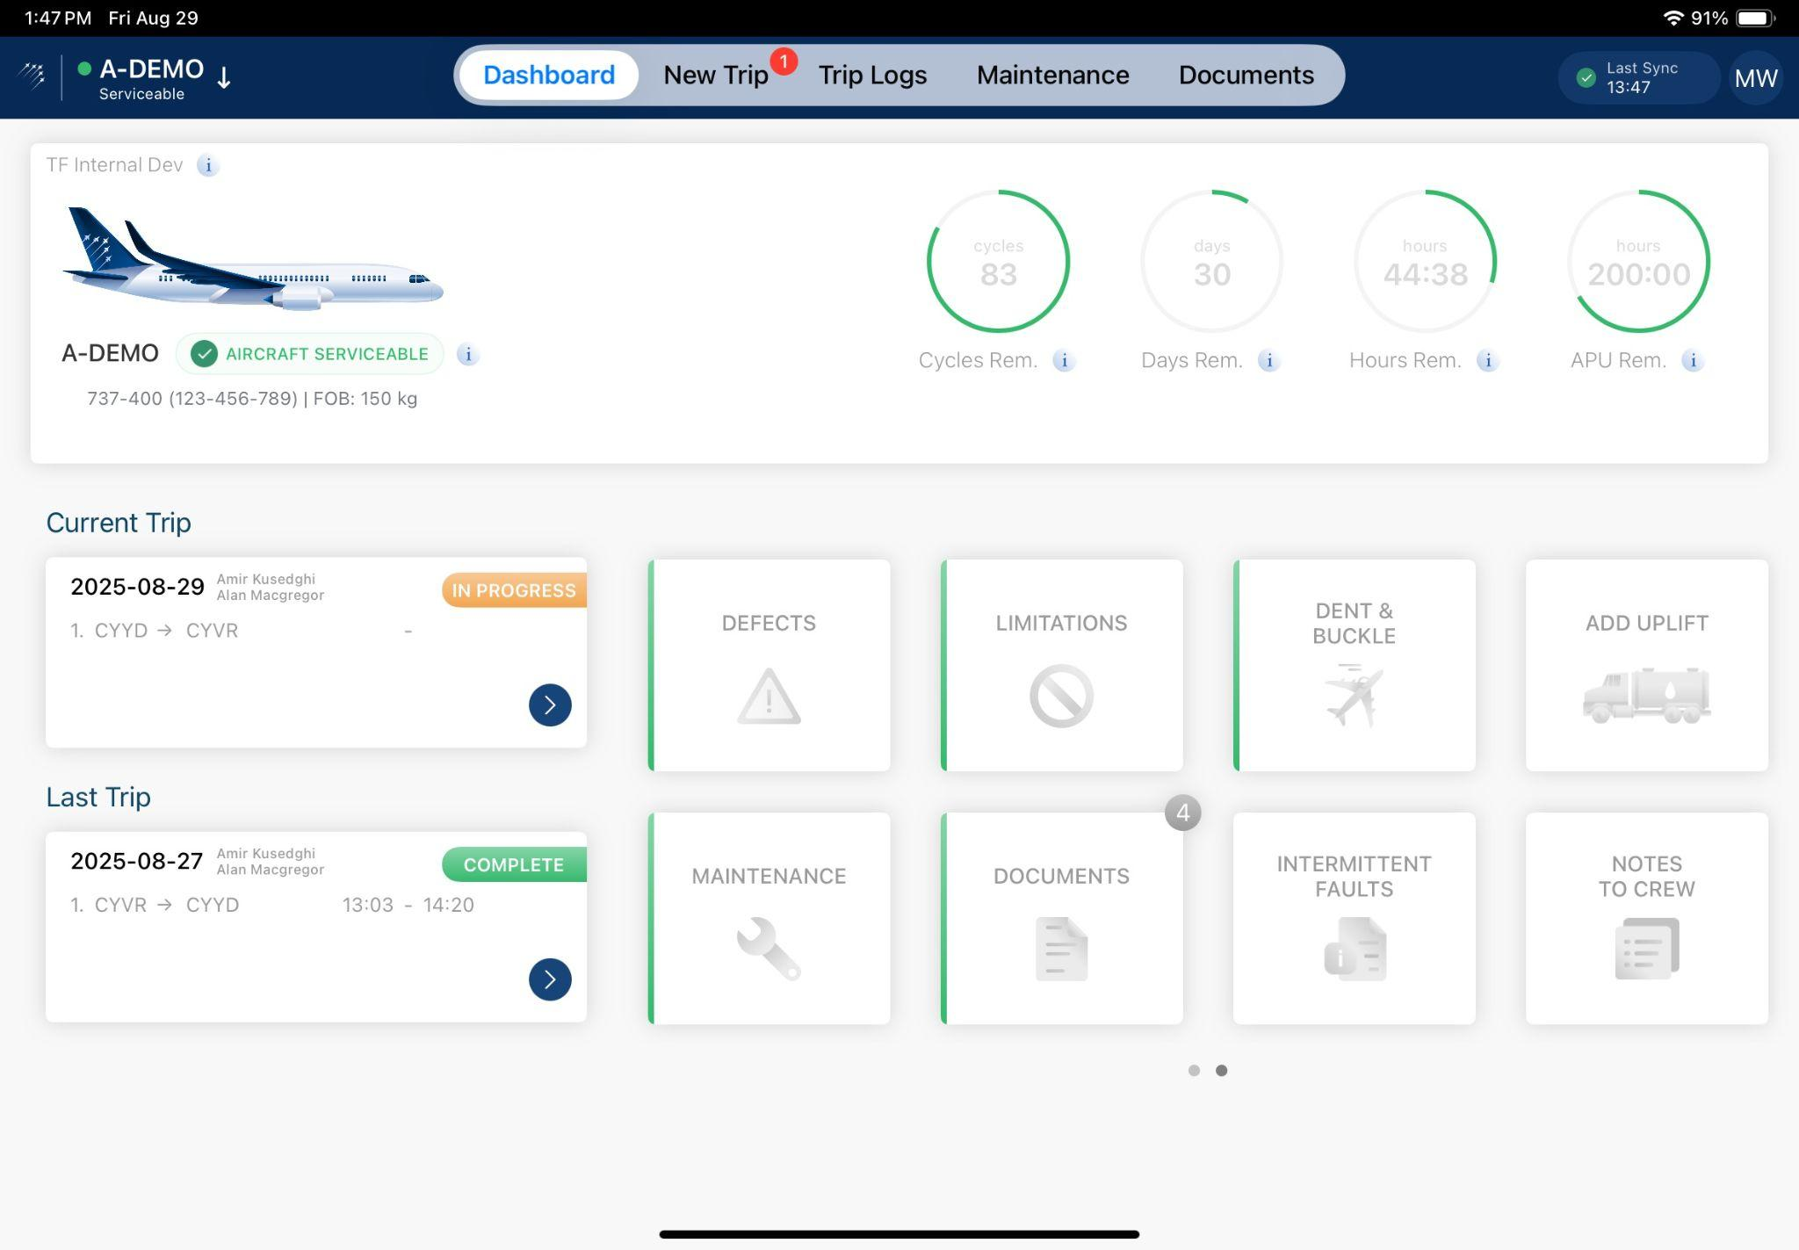 | TrustFlight’s Electronic Technical Logbook (eTLB), known as the Tech Log, is a web and mobile platform that modernizes how operators manage aircraft technical records, cabin condition reports, and journey data. Purpose-built for aviation, it enhances safety and operational efficiency by replacing paper-based processes with an intuitive, secure, regulation-ready digital solution.  Tech Log integrates with M&E systems to streamline operations, yet continues to operate independently during M&E outages. It supports technical, cabin, and journey entries, along with defect reporting, maintenance forecasting, and digital sign-offs for engineers and flight crews. Real-time dashboards and aircraft status reporting give maintenance control and flight operations teams full visibility into airworthiness and open items, in flight or on the ground. Integrated document management keeps manuals, MELs, and operational documents easily accessible and up to date. Optimized for device syncing, it works effectively in low-connectivity environments with automatic data synchronisation when reconnected.

Centrik 5
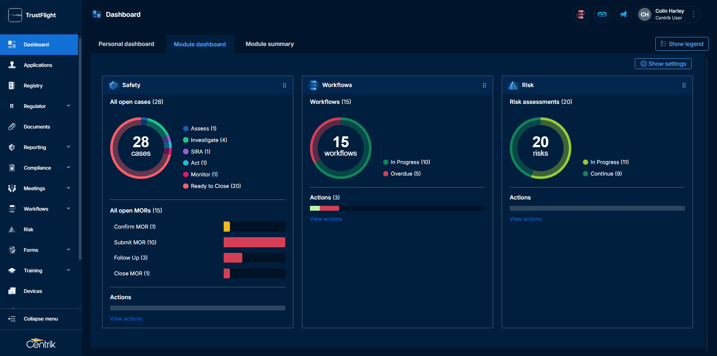 | Centrik 5, TrustFlight’s integrated Safety, Quality, and Risk Management System, is designed to enhance operational performance, reinforce accountability, and strengthen a resilient safety culture. Built specifically for aviation organisations, Centrik 5 unifies critical oversight functions into a single platform, delivering real-time visibility and structured workflows across departments.  As one of the industry’s most trusted SMS/QMS platforms, Centrik 5 helps operators not only meet regulatory requirements but exceed them—shifting from reactive compliance to proactive governance. The platform embeds safety and quality into daily operations, ensuring transparency, traceability, and continuous improvement. Centrik includes robust modules for Risk, Safety, Compliance, Document and Manual Control, Training, Meetings, and Electronic Flight Bags (EFBs), making it a truly all-in-one operational management system for aviation. Each module is designed for ease of use, with seamless interconnectivity that streamlines workflows and reduces duplication and administrative overhead.

MEL Manager
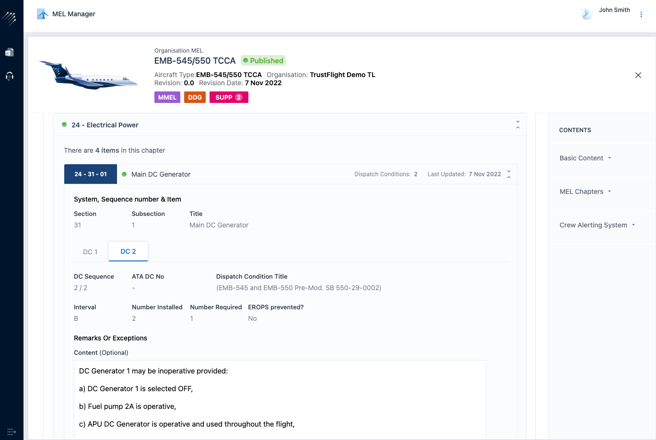 | TrustFlight’s MEL Manager streamlines the development, revision, and management of Minimum Equipment Lists (MELs) across an operator’s fleet. Fully integrated with the TrustFlight Tech Log, it enables rapid, accurate MEL creation through an interface that draws directly from a built-in Master MEL (MMEL) library.  Issuing a new MEL becomes a standardised, repeatable process—users select the relevant MMEL and apply operator-specific customisations through configurable workflows. Previously applied changes can be reused across aircraft and registries, reducing duplication and administrative effort. The system supports tailored MELs for individual aircraft while maintaining centralised fleet control, with built-in revision management, version control, and aircraft configuration tracking to ensure consistent compliance and remove the need for crews to cross-reference serial numbers.

Smart Documents
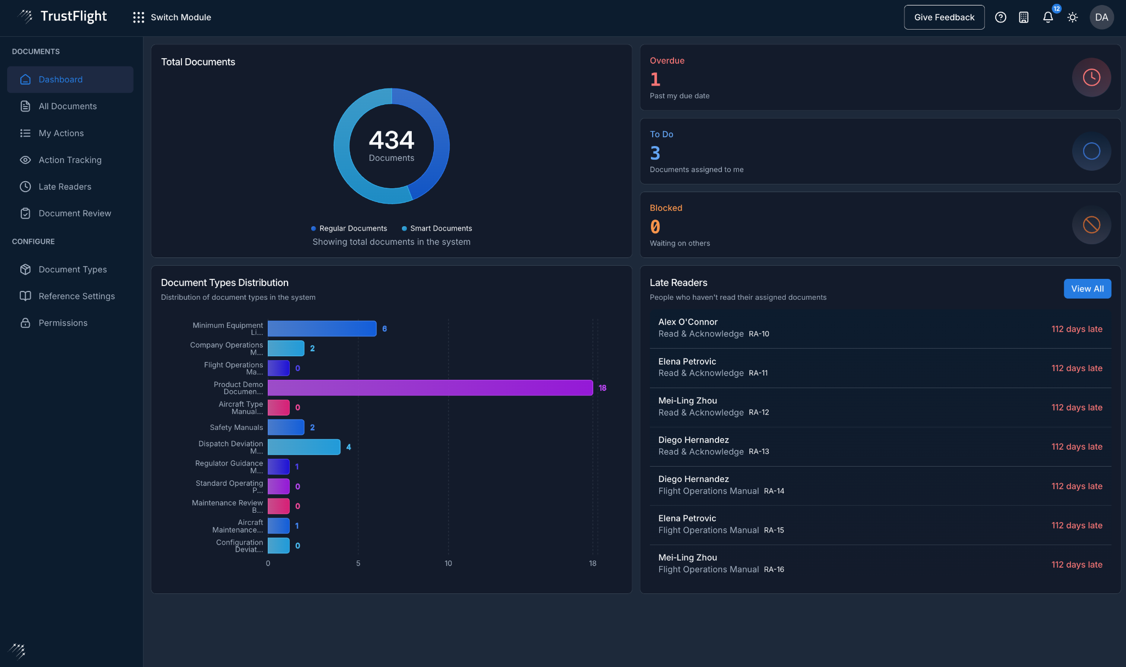 | Smart Documents is TrustFlight’s AI-powered document authoring and management platform for aviation operators. It streamlines the creation, review, and distribution of operational documents while maintaining consistency, compliance, and collaboration across departments.  The platform includes AI-generated templates, dynamic content suggestions, and real-time regulatory alerts to simplify authoring and reduce manual effort. A context-aware AI assistant surfaces relevant regulations and guidance as users draft, improving speed, accuracy, and regulatory alignment.  Smart Documents supports real-time collaboration, version control, and automated approvals, enabling faster document development and audit readiness. Accessible across devices, it lets teams author, edit, and access documentation securely from any location. Deployed standalone or integrated with Centrik 5, it centralises document management and removes silos between safety, quality, and operational teams. With Smart Documents, [COMPANY] can expect stronger document governance, reduced administrative workload, and faster alignment with evolving regulatory requirements.

Smart Regulations
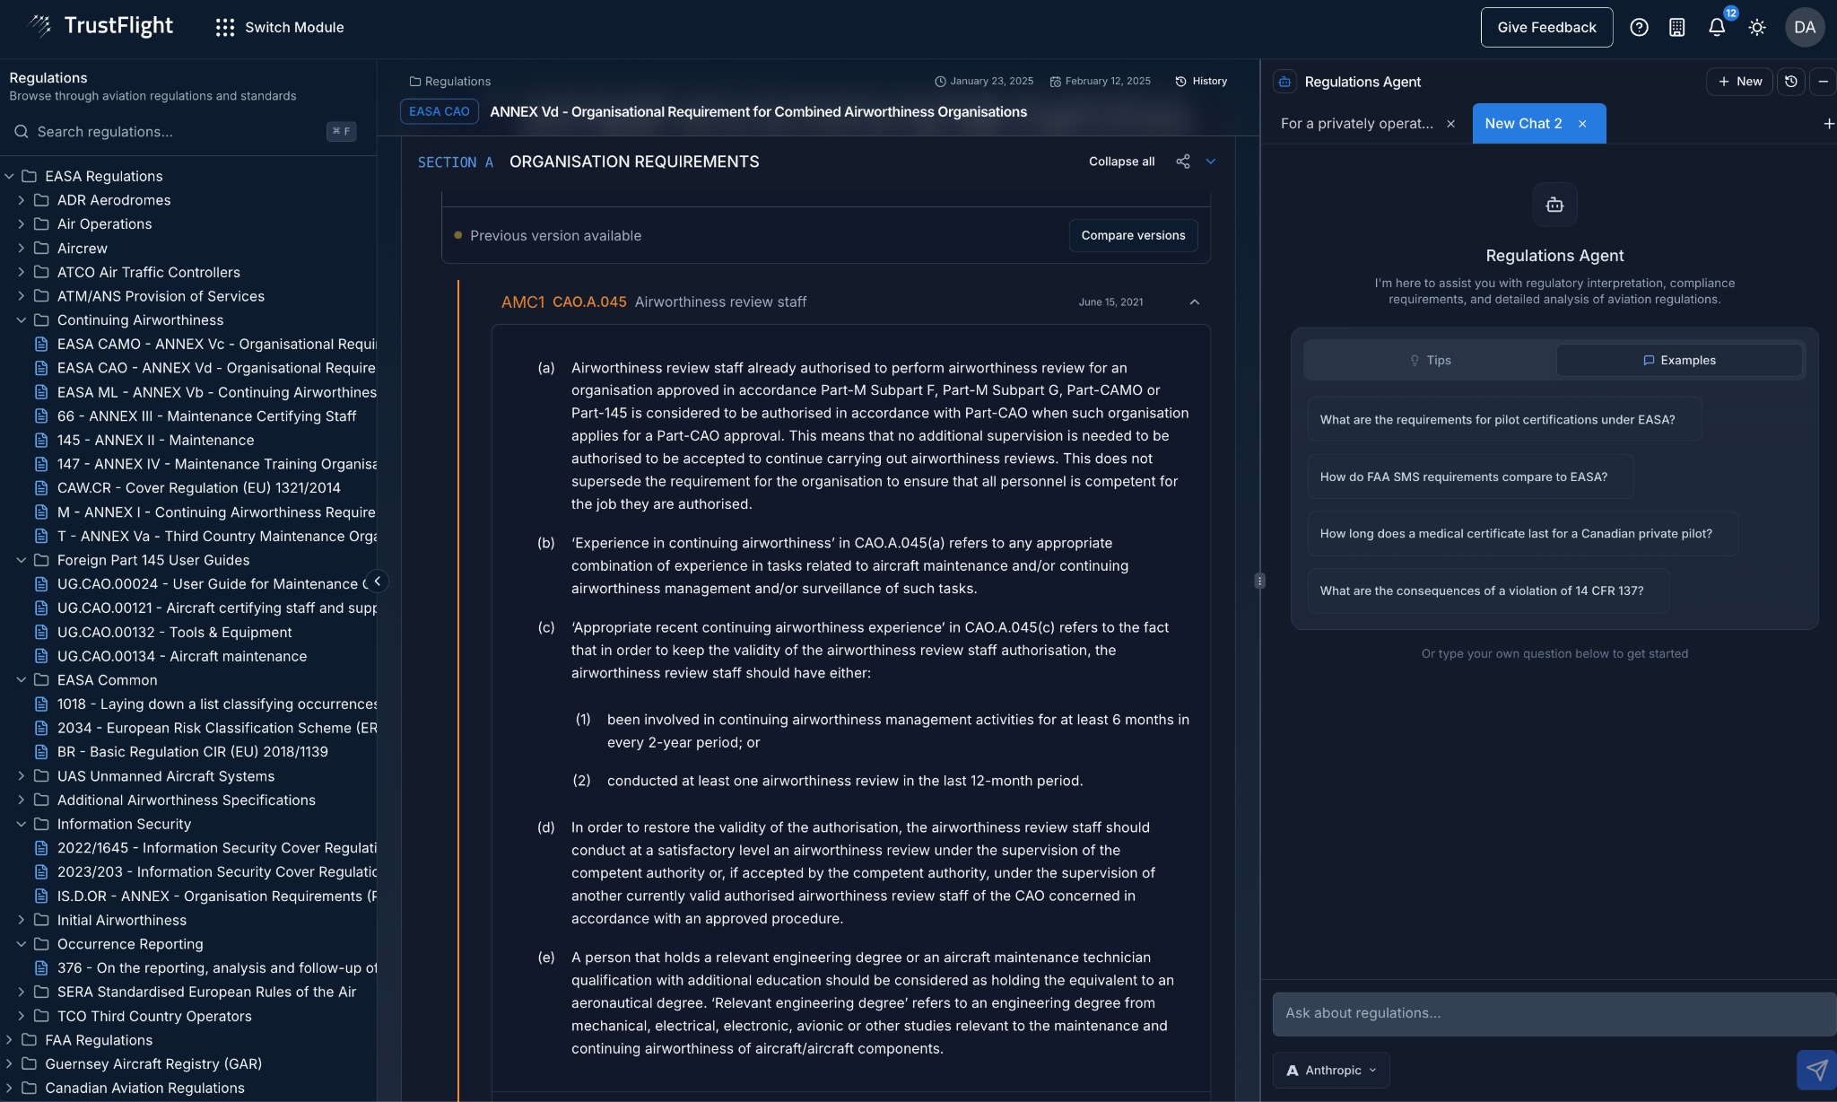 | Smart Regulations is TrustFlight’s agentic AI compliance platform that helps aviation organisations manage, interpret, and act on complex regulatory requirements. It shifts oversight from manual, reactive tasks to an intelligent, real-time process that strengthens audit readiness and operational decision-making.  The platform provides a continuously updated global database covering 120+ aviation regulatory frameworks. Users can quickly identify applicable standards, compare jurisdictions, and track amendments, while a chat-based AI assistant answers plain-language questions with citation-linked responses—reducing interpretation time and improving alignment.  Smart Regulations integrates with Smart Documents for in-line compliance during authoring and works with Centrik to link live regulations to procedures, audits, and risk registers. For [COMPANY], it offers a scalable tool that enhances regulatory awareness, reduces risk, and improves the efficiency of safety and quality functions.

Integration Ecosystem
TrustFlight offers a powerful and flexible integration platform, seamlessly connecting with more than 30 leading aviation software providers to streamline operations, enhance data accuracy, and improve efficiency across the industry.
Our robust API framework enables effortless data exchange between maintenance, compliance, safety, and flight operations systems, reducing manual processes and ensuring real-time synchronization. Whether integrating with fleet management, Maintenance and Engineering (M&E) software, flight planning, or regulatory compliance solutions, TrustFlight’s integration ecosystem empowers aviation organizations to leverage their existing technology stack while unlocking the full potential of digital transformation. And if you don’t see the integration you need, our dedicated integrations team is ready to develop custom solutions to ensure seamless connectivity across your operations. For a full list of our available integrations, please visit www.trustflight.com/integrations.
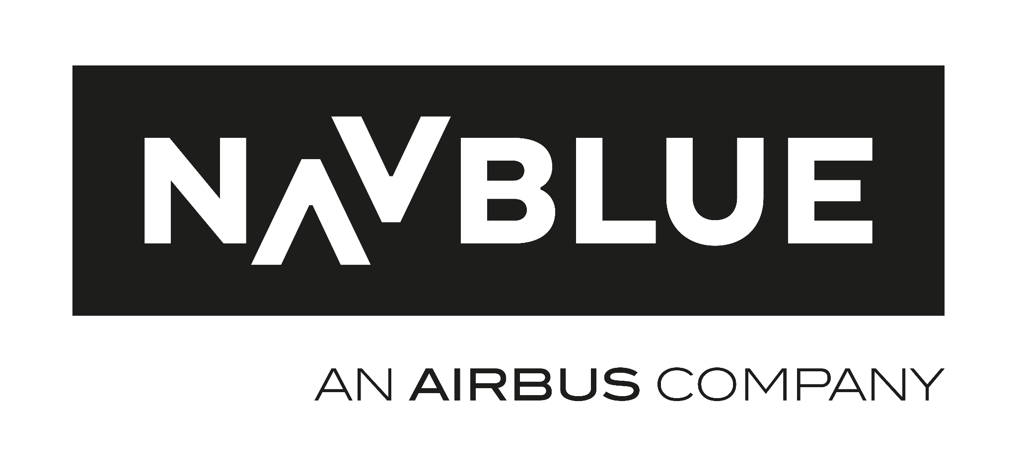

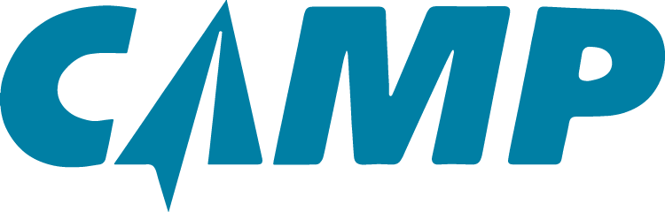

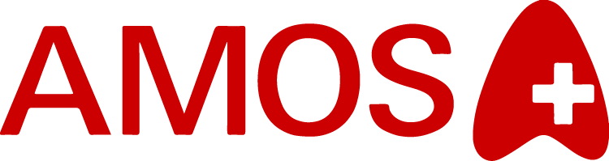
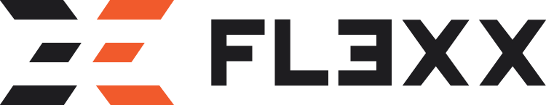
…and many others.

Implementation Experience
TrustFlight has conducted over 450 software implementations on over 750 AOCs globally. Our portfolio of development solutions and implementation experience is recognized globally for agility, attention to detail, and on-time delivery. Our implementation process, driven by a consultative and collaborative framework, is outlined in the table below. TrustFlight also has extensive experience working with global regulators to achieve compliance and regulatory approvals.






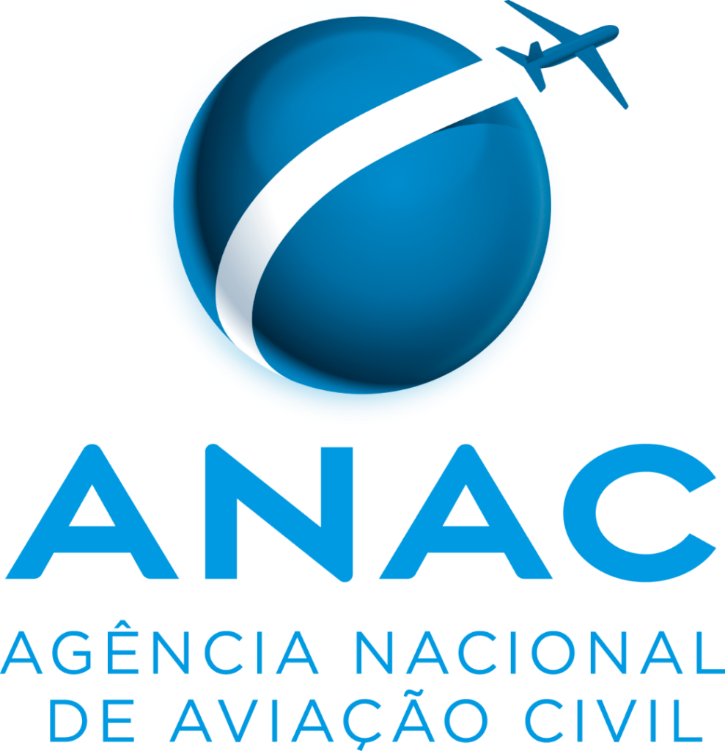

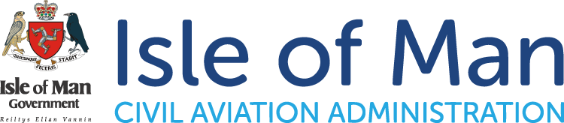


Tech Log Technical Overview

Functional Description

Tech Log Overview
TrustFlight’s Electronic Technical Logbook (eTLB), known as the Tech Log, is a comprehensive, web and mobile app-based platform designed to modernize how operators manage aircraft technical records, cabin condition reports, and journey data. Purpose-built for aviation, the system enhances both safety and operational efficiency by replacing paper-based processes with a digital-first solution that is intuitive, secure, and regulation-ready. Tech Log integrates directly with AMOS to streamline operations—but unlike traditional systems, it keeps working even if AMOS fails.


Figure 1. TrustFlight Tech Log dashboard.

Tech Log supports the full range of logging activities, including technical, cabin, and journey entries, while also enabling seamless defect reporting, maintenance forecasting, and digital sign-offs for engineers and flight crew. Its real-time dashboard and aircraft status reporting give maintenance control and flight operations teams complete visibility into aircraft airworthiness and outstanding items, whether on the ground or in the air. Beyond logging, Tech Log includes integrated document management, ensuring that aircraft-related manuals, MELs, and operational documentation are readily accessible and always up to date. The system is optimized for device syncing, allowing users to operate effectively even in low-connectivity environments, with automatic data synchronization when reconnected.
TrustFlight provides end-to-end implementation support, from integration with existing maintenance and operations systems to training and onboarding, ensuring a smooth transition and rapid value realization. With a focus on usability, compliance, and interoperability, Tech Log empowers operators to make informed decisions, reduce delays, and streamline maintenance workflows in real time.

Tech Log Capabilities Matrix
TrustFlight Tech Log | Capabilities
Flight Log
Flight Log | Record flight sector details. Support for multi-sector or single-sector logs.
Journey Log | Accurately track journey log details including crew duty, passengers & other operational data.
Custom PDF Tech Log & Journey Log Page | Onboard your existing, approved Electronic Tech Log & Journey Log pages to make implementation quick and easy.
SMS Integration | Raise safety reports directly from the Electronic Tech Log and pre-populate with relevant defect and flight data.
FRAT Module | Raise Flight Risk Assessment Tool (FRAT) reports directly from within the flight workflow.
Scheduling Integration | Import scheduled flight and crew information. Export completed flight entries & crew duty back into the scheduling system.
Customizable Fuel Uplifts | Configure Fuel Uplifts to track fuel by tank, type of fuel (eg. SAF) and variable SG amounts. Validation alerts on fuel uplift discrepancies.
Refueling Receipts with Payments | Digitize and manage refueling receipts for on-the-fly record-keeping with payments and accounts compliance.
Defect Reporting
Defect Log | Efficiently log and track aircraft defects for timely resolution.
Cabin Log with Interactive Layout | Record and manage all cabin-related issues with ease and accuracy. Captain approval/escalation process for cabin items.
Custom Deferred Defect Log Page | Onboard your existing deferred defect report template to make implementation of the system quick and easy.
Intermittent Faults | Accurately track and analyze intermittent faults for improved diagnostics. Track occurrences and escalate to a defect.
Deferral Management (MEL, CDL, NEF) | Streamline deferral processes with integrated workflows and approvals.
Embedded MELs with Linked (O)&(M) Procedures | Access and apply Minimum Equipment Lists directly within the system for real-time compliance checks.
Maintenance Forecast and Sign-Offs
Component Install/Removal Recording | Record component install and removal activities with complete audit trails.
Third Party Maintenance Sign-Offs | Workflow for third-party maintenance providers to electronically sign-off logs and release aircraft.
Workflow Support for Deferrals | Full workflow support for different deferrals, including MEL, CDL, and NEF.
Bi-directional M&E Integration | Seamlessly integrate with popular M&E systems for utilization, defects, deferrals, maintenance actions, and maintenance forecasts.
Line Maintenance Checks | Workflows to conduct scheduled line maintenance activities such as preflight checks, daily checks & weekly checks.
Maintenance Task Initiation | Initiate maintenance tasks quickly with automated, system-driven processes. Create workpacks directly in the system.
Dent & Buckle Chart | Interactive chart to record and display known airframe damage. Upload customized aircraft dent & buckle charts.
Fluid Uplifts | Record and manage hydraulic and oil uplifts accurately and efficiently.
Authority-Approved Electronic Sign-Offs | Ensure regulatory compliance with approved electronic sign-offs by FAA, EASA, and TCCA.
Dashboard and Status Reporting
Real-Time Fleet Status Dashboards | Monitor entire fleet status instantly with dynamic, real-time dashboards.
Real-Time Alerts & Notifications | Stay informed with email and SMS notifications for critical updates.
Crew Handover Module | Allow ops teams to seamlessly communicate and report items between different crew members using the aircraft.
Data Exporting (CSV/PDF/XML/API) | Easily export data for analysis and reporting with versatile business intelligence tools.
Document Management
Document Viewer | Instantly view and interact with documents both online and offline through an integrated viewer.
Document Hosting | Securely host and manage documents in a centralized cloud-based platform.
Document Sharing | Facilitate easy and secure sharing of documents across teams and systems.
EFB Document Integration | Import documents from external systems to show on the EFB. Automatically downloaded and viewable offline.
Device Syncing and User Capabilities
Multiple Deployment Options | Deploy your ETL as a fixed device on the aircraft and/or a dedicated device for pilots or engineers with the ability to re-use existing iPads.
Real-Time Device Syncing | Synchronize data across devices instantly for up-to-date information.
True Electronic Signature | Authenticate documents securely with legally binding electronic signatures approved by FAA, EASA, TCCA, CASA, and others.
Unlimited Data | Enjoy unrestricted data storage for comprehensive record-keeping.
Unlimited Users | Allow limitless user access for scalable team collaboration.
Offline Mode Capability | Ensure continuous operation even without internet access. Specific backup procedures designed for the scenario of no connectivity.
Calculated Fields | Automate computations with fields that calculate data dynamically.
Self-Service Configurability | Tailor interface layouts to meet specific user needs and preferences. All available for an admin to change via self-service settings.
Version Control | Maintain document integrity with robust version tracking and control.
Implementation Support
Onsite and Remote Implementation | Gain experienced implementation support from aviation SMEs for procedure changes, training, and regulatory approval support.
Organization-Specific Forms | Leverage existing forms and documents and map them to your internal processes and workflows.
QR and Pin Code Validation | Identify the correct aircraft/user with easy-to-use app-based QR/Pin code validation.
24/7 Implementation and Post- Implemenetation Support | Ensure operational resilience with a dedicated implementation executive and post-implementation support on-call.

Tech Log Implementation Schedule

Dedicated Project Management
TrustFlight will assign a dedicated Implementation Executive to oversee the [PRODUCT] implementation for [COMPANY]. This individual will serve as the single point of contact, responsible for coordinating the implementation timeline, managing internal and customer-side resources, executing system configuration, leading training sessions, and ensuring clear, consistent communication throughout the engagement. The Implementation Executive will work collaboratively with [COMPANY]’s internal stakeholders to maintain alignment and accountability across all phases of the project.

Frequency and Method of Communication
TrustFlight adopts a flexible communication approach tailored to the preferences and operational cadence of [COMPANY]. Communication frequency and format will be defined in collaboration with [COMPANY] during project planning and adjusted as needed throughout the program to match progress milestones, task dependencies, and stakeholder availability.
Standard communication methods include virtual video calls, email updates, and telephone discussions, with on-site meetings arranged as required to support key stages such as kick-off, training, or go-live. TrustFlight is committed to adapting to [COMPANY]'s internal communication protocols and tools as needed to ensure seamless coordination and documentation of all project activities.

Implementation Experience
TrustFlight has successfully delivered over 450 customer implementations across more than 750 AOCs globally. Our solutions are trusted by operators in highly regulated jurisdictions due to our track record of agile delivery, operational insight, and consistent on-time execution.
The implementation process follows a consultative and collaborative framework, described in Table 7, and is designed to ensure smooth onboarding, knowledge transfer, and stakeholder alignment at every stage. Our team includes regulatory experts and project specialists with direct experience working with national and international aviation authorities, ensuring a clear path to compliance and full support during approval and audit processes.

Tech Log Implementation Framework
Proposed Time Frame Associated with Implementation
Onboarding and Reviews | Implementation & Configuration | Training | Parallel Trial
System Setup | Custom Enhancements | Final Configuration | Seek Feedback
Product Walkthrough | Document Onboarding | Train the Trainer
Review and Proposal  Agreements | Project Management | Promote Industry Best Practice
 | Ongoing Configuration | Other Training Workshops as  Required
Provide Access to Learning
Materials
 | Integrations
 | UAT

Proposed Schedule
TrustFlight has estimated a total implementation timeline of no more than 3 months, and will follow the implementation summary
outlined in Table 8. However, this may shift after further discussions with [COMPANY], the entire scope of work, and timelines
associated with integration initiatives. This schedule was formed without prior knowledge of [COMPANY] complete Statement of
Work, timeline, integrations, training requirements, etc., and is an estimation based on past implementations with airline customers.
This timeline is not a binding timeline—consultations with [COMPANY] must take place in order to define an official implementation
schedule. TrustFlight looks forward to additional discussions to finalize the implementation schedule with [COMPANY].

Proposed Time Frame Associated with Implementation
Phase | Detail | Time Frame (HR: MIN)
Pre-Implementation | Scoping Call | 1:00
Implementation | Client Setup | 2:00
Configuration | Contacts | 4:00
 | Documents | 8:00
 | Safety Reports | 4:00
 | Security Reports | 4:00
 | Other | 2:00
 | Risk | 8:00
 | Quality/Compliance | 16:00
 | Training | 10:00
Training | Contacts | 1:30
 | Safety | 3:00
 | Risk | 2:00
 | Quality/Compliance | 3:00
 | Meetings | 1:30
Roll Out | *Site Visit (if applicable) | 20:00
Post-Implementation | Follow Up Calls | 3:00
Handover to Support | Final Call | 1:00
Total Estimated Average |  | 99.0 Hours

The schedule quoted here excludes a) email and phone based communication and b) data upload (imports).

SLAs
TrustFlight's infrastructure team is committed to ensuring the highest service levels to our global customer base. We pride ourselves on rapid communications from our support and implementation teams, which are located across the globe ensuring you're met with live representation when needed.

TrustFlight Customer Support SLAs |  | Unit Price (USD)
Severity | Definition | Response Time  (From First Notification) | Resolution Time
Low | Minor defects that do not prevent effective usage of the system, or have ready workarounds. | 1 Day | No commitment
Medium | Recurring defects impacting localized features that do not meet the above criteria above.  Eg. Managers are unable to download a report as desired. | 2 Hours | 1 Week
High | Limited degradation of system preventing use of key features and impacting at least 20% of users  Eg. Users are unable to submit reports/records. | 1 Hour | 1 Working Day
Critical | Complete outage of system or serious degradation impacting 80% of users. | 30 Minutes | 2 Hours
TrustFlight can work with [COMPANY] to offer customized SLAs as needed that best fits their operational requirements.

Centrik 5 Technical Overview

Functional Description

Centrik 5 Overview
Centrik 5 is TrustFlight’s flagship operational management system, purpose-built for the rigorous demands of commercial aviation. Designed to enhance efficiency, standardization, and accountability, Centrik provides an integrated platform for managing all Safety, Quality, and Risk functions in one secure, configurable environment.


Figure 2. TrustFlight Centrik 5 module dashboard.

The system includes fully integrated modules for Risk, Safety, Compliance, Manuals, Document Control, Training, Meetings, Electronic Flight Bags (EFBs) and more—providing a single source of truth across departments and locations. This eliminates duplication, streamlines oversight, and strengthens coordination between operational teams.
A key differentiator is Centrik’s Regulations Subscription Service, which hosts public domain frameworks such as IOSA directly within the platform. Users receive real-time alerts when regulatory changes occur, ensuring immediate visibility and simplifying ongoing compliance management.
Each user is assigned a customizable dashboard tailored to their job function, accessible from any device. Dashboards provide real-time visibility into assigned tasks, outstanding actions, and relevant documents, while enabling direct access for third parties, contractors, and suppliers—removing the need for manual data entry and reducing administrative burden.
Management users benefit from complete organizational oversight, with visibility into the performance and compliance status of individuals, teams, and functional areas—supporting transparency, accountability, and informed decision-making. Centrik’s intuitive traffic light system allows rapid status assessments and action tracking, simplifying operational monitoring at all levels.
Centrik is continuously evolving in close partnership with airlines, regulators, airports, and industry leaders worldwide. This ensures the system remains aligned with emerging best practices and the dynamic regulatory environment facing modern aviation organizations.

Centrik 5 Capabilities Matrix
TrustFlight Centrik 5 | Capabilities
Safety | - Capture incident and hazard reports  - Classify reports, including the risk level  - Conduct and record investigative actions  - Conduct in-depth risk assessments if required  - Act on risk assessment findings  - Monitor the risk within set timeframes  - File mandatory occurrence reports to the aviation authority  - Analyse reports in heatmaps and KPIs
Compliance | - Maintain audit plans  - Maintain audit checklists, linked with aviation regulations  - Conduct audits  - Raise and categorise findings  - Assign findings to individuals for resolution  - Construct and track action plans  - Manage finding closure  - Analyse findings in heatmaps and KPIs
Risk | - Conduct multi-hazard, multi-consequence risk assessments using customisable risk matrices  - Configure templates for standard risk assessments  - Track repeat risk assessment and evolution of risk  - Assess risk before and after mitigation  - Define and track mitigating actions  - Compare risk assessment results with real-life data from findings and incidents  - Analyse risks and hazards in heatmaps and KPIs
Documents | - Host documents, for example Ops Manuals, Forms, Briefings, Notices to staff, Staff Procedure documents etc.  - Monitor documents for required reviews and expiry  - Track which staff have read or have not read documents  - Send reminders to non-readers  - Replicate documents to offline devices (iPad, Android)  - See which devices are up-to-date and which have to be updated
Regulations Update Service | - Monitoring of subscribed regulations and frameworks for changes (e.g., IOSA, EASA, FAA, TCCA)  - Updating regulations in the Customer’s Application with new revisions for revision and acceptance  - Change review process showing linked objects (e.g., Compliance checklists)
Meetings | - Schedule, track and minute meetings  - Distribute agenda and minutes to attendees  - Generate KPI reports from other modules and attach them to meetings  - Assign and track meeting actions  - Configure workflows, from simple ‘to do list’ to complex flows including e.g., risk assessments, audits  - Execute workflows – assign steps, set deadlines, track progress  - Complete forms, e.g., discretion report, new employee  - Trigger workflows on submission of forms
ERP | - Automated workflows to trigger real-time phone calls and text messages to designated personnel under emergency response conditions
Workflows | - Configure workflows, from simple ‘to-do list’ to complex flows across modules  - Execute workflows – assign steps, set deadlines, track progress
Equipment | - Track assets, manage defects, and create maintenance programmes
Training | - Paperless, digital training solution with offline capabilities and tracking of staff currency, upcoming expiries and scheduled training  - Manage and issue company authorisations, create line check, LIFUS and phased training courses  - Staff training self-upload  - Easily configurable role based training  - Multi department / organisation training areas

Centrik 5 Implementation Schedule

Dedicated Project Management
TrustFlight will assign a dedicated Implementation Executive to oversee the [PRODUCT] implementation for [COMPANY]. This individual will serve as the single point of contact, responsible for coordinating the implementation timeline, managing internal and customer-side resources, executing system configuration, leading training sessions, and ensuring clear, consistent communication throughout the engagement. The Implementation Executive will work collaboratively with [COMPANY]’s internal stakeholders to maintain alignment and accountability across all phases of the project.

Frequency and Method of Communication
TrustFlight adopts a flexible communication approach tailored to the preferences and operational cadence of [COMPANY]. Communication frequency and format will be defined in collaboration with [COMPANY] during project planning and adjusted as needed throughout the program to match progress milestones, task dependencies, and stakeholder availability.
Standard communication methods include virtual video calls, email updates, and telephone discussions, with on-site meetings arranged as required to support key stages such as kick-off, training, or go-live. TrustFlight is committed to adapting to [COMPANY]'s internal communication protocols and tools as needed to ensure seamless coordination and documentation of all project activities.

Implementation Experience
TrustFlight has successfully delivered over 450 customer implementations across more than 750 AOCs globally. Our solutions are trusted by operators in highly regulated jurisdictions due to our track record of agile delivery, operational insight, and consistent on-time execution.
The implementation process follows a consultative and collaborative framework, described in Table 7, and is designed to ensure smooth onboarding, knowledge transfer, and stakeholder alignment at every stage. Our team includes regulatory experts and project specialists with direct experience working with national and international aviation authorities, ensuring a clear path to compliance and full support during approval and audit processes.

Table 1. [PRODUCT] Implementation Framework
Implementation Framework
Set Up | Configure | Roll Out | Support
Create Live & Test Sites | Formulate Site Structure | Final Configuration | Seek Feedback
Initiate Implementation Workflow | Initiate Data Migration | Train the Trainer | Explain Use of ZenDesk
Grant Access to Centrik Admins | Project Manage Implementation | Promote Industry Best Practice
Upload Contact Lists | Ongoing Configuration | Other Training Workshops as Required
Understand Client Requirements | Provide Access to Learning Material
Agree Upon Implementation Timeline | Communicate Desired Structure Across Modules
Manage Expectations | Configure Roles and Departmental Structure
Assist with Management of Change | Resolve Access Rights

As outlined in the table above, the implementation process begins with the Set-Up phase and concludes with the Support phase. The duration of this framework varies depending on the complexity of the operator. While implementations can range from 1–2 months for straightforward deployments to 12–24 months for large, multi-base or highly customized environments, the average implementation timeline is 4–6 months. The final project schedule is defined in collaboration with the customer during the planning phase and is tailored to operational needs, resource availability, and integration requirements.

Proposed Schedule
TrustFlight has estimated a total implementation timeline of no more than 3 months, and will follow the implementation summary
outlined in Table 8. However, this may shift after further discussions with [COMPANY], the entire scope of work, and timelines
associated with integration initiatives. This schedule was formed without prior knowledge of [COMPANY] complete Statement of
Work, timeline, integrations, training requirements, etc., and is an estimation based on past implementations with airline customers.
This timeline is not a binding timeline—consultations with [COMPANY] must take place in order to define an official implementation
schedule. TrustFlight looks forward to additional discussions to finalize the implementation schedule with [COMPANY].

Table 2. Sample [PRODUCT] Implementation Timeline.
Proposed Time Frame Associated with Implementation
Phase | Detail | Time Frame (HR: MIN)
Pre-Implementation | Scoping Call | 1:00
Implementation | Client Setup | 2:00
Configuration | Contacts | 4:00
 | Documents | 8:00
 | Safety Reports | 4:00
 | Security Reports | 4:00
 | Other | 2:00
 | Risk | 8:00
 | Quality/Compliance | 16:00
 | Training | 10:00
Training | Contacts | 1:30
 | Safety | 3:00
 | Risk | 2:00
 | Quality/Compliance | 3:00
 | Meetings | 1:30
Roll Out | *Site Visit (if applicable) | 20:00
Post-Implementation | Follow Up Calls | 3:00
Handover to Support | Final Call | 1:00
Total Estimated Average |  | 99.0 Hours

The schedule quoted here excludes a) email and phone based communication and b) data upload (imports).

Integrations
TrustFlight’s Centrik is designed with integration at the core, ensuring seamless connectivity with the broader operational technology ecosystem used by modern aviation operators. Our platforms are built on open, API-first architectures that enable secure, scalable, and efficient integration with third-party systems.
TrustFlight supports out-of-the-box or proven integrations with a range of industry platforms, including:
- Flight Data Monitoring (FDM) applications and platforms
- Business Intelligence tools including Power BI
- Flight scheduling and operations platforms
- Crew training and HR platforms for automated syncing of training records and personnel qualifications
- Single Sign-On (SSO) integrations with identity providers such as Microsoft Azure AD and Okta
These integrations ensure data flows securely and efficiently between departments, eliminating duplication, improving accuracy, and enabling real-time operational oversight. They also reduce manual workload and ensure consistency across compliance, safety, engineering, and flight operations workflows.
For [COMPANY], TrustFlight can interface directly with your preferred systems to support automation of key data exchanges—such as safety event data from FDM, maintenance defect transfers between Tech Log and MRO systems, and audit readiness tracking from regulatory documents to risk registers.
Our implementation team will work closely with [COMPANY]’s IT and operational stakeholders to define integration requirements and ensure smooth connectivity with minimal disruption. TrustFlight’s integration strategy is built to support both immediate operational value and long-term digital scalability.

Technical Description
A complete technical description, including system architecture, infrastructure, APIs, hosting, backups, disaster recovery, and more, is available for review in the attached document titled 'Centrik Technical Overview V5'.

SLAs
TrustFlight's infrastructure team is committed to ensuring the highest service levels to our global customer base. We pride ourselves on rapid communications from our support and implementation teams, which are located across the globe ensuring you're met with live representation when needed.

TrustFlight Customer Support SLAs |  | Unit Price (USD)
Severity | Definition | Response Time  (From First Notification) | Resolution Time
Low | Minor defects that do not prevent effective usage of the system, or have ready workarounds. | 1 Day | No commitment
Medium | Recurring defects impacting localized features that do not meet the above criteria above.  Eg. Managers are unable to download a report as desired. | 2 Hours | 1 Week
High | Limited degradation of system preventing use of key features and impacting at least 20% of users  Eg. Users are unable to submit reports/records. | 1 Hour | 1 Working Day
Critical | Complete outage of system or serious degradation impacting 80% of users. | 30 Minutes | 2 Hours
TrustFlight can work with [COMPANY] to offer customized SLAs as needed that best fits their operational requirements.

Training
TrustFlight has a training team that is available for both virtual and in-person sessions, as well as a customer success team that ensures [COMPANY] has the resources it needs to succeed. Upon commencing implementation, TrustFlight employs a "train-the-trainer" approach, giving [COMPANY] the ability to train teams as needed on their own schedules and timelines. However, all materials, training videos, and other documentation will be provided at no cost to [COMPANY] and are included as part of the Implementation process.

Data Migration
Centrik offers a comprehensive data migration solution to ensure a seamless transition from your legacy system. Our experienced team works closely with you to map, transfer, and validate critical data, maintaining its integrity and accuracy throughout the process. Leveraging proven methodologies, we minimize disruption and ensure that historical records, compliance documentation, and operational data are seamlessly integrated into Centrik’s platform. With meticulous planning and testing, we deliver a migration process that is efficient, secure, and tailored to your organization’s unique requirements, enabling a smooth onboarding experience and uninterrupted operations.

Smart Suite Technical Overview

Functional Description

Smart Documents Overview
Smart Documents is TrustFlight’s AI-powered document authoring and management platform, purpose-built for aviation operators. It enables the streamlined creation, review, and distribution of operational documents while ensuring consistency, compliance, and collaboration across departments.


Figure 3. TrustFlight Smart Documents dashboard.

Smart Documents supports real-time collaboration, version control, and automated approval workflows, enabling faster document development and audit readiness. The platform is accessible across devices, ensuring operational teams can author, edit, and access documentation securely from any location.
Smart Documents can be deployed as a standalone solution or integrated directly with Centrik 5, centralizing document management and eliminating information silos between safety, quality, and operational teams.
With Smart Documents, [COMPANY] can expect improved document governance, reduced administrative workload, and faster alignment with evolving regulatory requirements.

Smart Documents Capabilities Matrix
TrustFlight Smart Documents | Capabilities
Intelligent Authoring & AI Assistance | Word-style aviation authoring environment with structured chapters, front matter, and dynamic elements; AI PDF Importer for converting legacy PDFs into editable SmartDocs; AI Document Assistant grounded in regulations and existing manuals; AI-generated, aviation-specific templates based on regulatory frameworks and best practices.
Document Lifecycle & Control | Full document lifecycle management from draft to archive; hierarchical folders, tags, and document types; robust versioning with comparison, change bars, and section-level history; configurable multi-step review and approval workflows; text-anchored change requests integrated into drafting; integrated actions dashboard for reviewers/approvers; bulk onboarding of existing documents via AI PDF importer and optional services.
Distribution, Readership & User Experience | Targeted distribution by user, role, and organisational unit; Read & Acknowledge tracking with automated reminders; modern HTML reader plus professional PDF layouts; paginated PDF export with headers, TOC, LoES and dynamic Smart Objects; SmartSuite iPad app for offline access with automatic sync; powerful full-text and metadata search for rapid discovery.
Regulatory Intelligence & Compliance | Section-level linking between SmartDocs content and SmartRegs regulatory requirements; automatic alerts when underlying regulations change; regulatory impact analysis showing affected documents; continuous monitoring of link integrity to identify outdated or broken references; roadmap feature for document-to-document impact analysis driven by governance and regulations (Q1 2026).
Platform Security, Access & Identity | SmartSuite APIs with an expanding integration roadmap; optional, non-mandatory integration to Centrik for PDF publishing for operators already using Centrik; SmartDocs remains fully functional as a standalone DMS.
Integrations & Ecosystem | SmartSuite APIs with an expanding integration roadmap; optional, non-mandatory integration to Centrik for PDF publishing for operators already using Centrik; SmartDocs remains fully functional as a standalone DMS.

Smart Documents Product Roadmap
TrustFlight Smart Documents Product Roadmap
Feature | Description | Planned Release
Cross-Document Links for SmartDocs | The Cross-Document Links feature extends Regulation Links to SmartDocs, letting users create structured, traceable references between headings in different documents, with the option to include child sections. As with Regulation Links, authors are proactively notified if a linked section becomes outdated, changed, or broken. | Jan 2026
Programmatic Document Numbers & Index | Provides Document Managers and Authors with intelligent document numbering assistance that provides automated suggestions and real-time validation along with a document number index to easily identify and manage document number assignment. | Jan 2026
Smart Acronyms, Definitions, Glossary and Index | This feature lets authors easily insert Smart Acronyms and Smart Definitions from a centrally managed list, ensuring consistent terminology across documents. Readers can hover over acronyms and terms to see definitions in the digital reader, while automatically generated glossaries and indexes make it simple to find key terms and where they appear. Both are available digitally and as placeholders that populate when exporting to PDF. | Jan 2026

Smart Regulations Overview
Smart Regulations is TrustFlight’s agentic AI compliance solution, designed to help aviation organizations manage, interpret, and act on complex regulatory requirements with speed and precision. It transforms regulatory oversight from a manual, reactive task into a real-time, intelligent process—improving both audit readiness and operational decision-making.


Figure 4. TrustFlight Smart Regulations dashboard.

The platform provides access to a comprehensive, continuously updated global aviation regulations database, covering over 120 regulatory frameworks. Users can instantly identify applicable standards, compare jurisdictional differences, and track amendments— ensuring compliance across multiple authorities and regions.
A built-in chat-based AI assistant allows users to ask regulatory questions in plain language and receive accurate, citation-linked answers on demand. This reduces time spent interpreting rules, improves clarity, and supports faster alignment across departments.
Smart Regulations also integrates with Smart Documents to provide in-line compliance support during authoring and can be used independently or in tandem with Centrik to connect live regulations to procedures, audits, and risk registers.

Smart Regulations Capabilities Matrix
TrustFlight Smart Regulations | Capabilities
Global Regulations Access | Access over 120 international aviation regulatory frameworks to get intelligent, context-aware compliance assistance for any purpose.
Amendment Tracking | Track amendments with detailed side-by-side comparisons, enabling compliance teams to instantly identify changes across jurisdictions, assess regulatory impact, and confidently update internal policies, manuals, and checklists in real-time.
Real-Time Answers | Receive intelligent, context-aware responses to regulatory queries, empowering teams to quickly interpret complex clauses, resolve compliance uncertainties, and access citation-linked answers grounded in most current regulatory frameworks.
Validation With References | Verify all responses with direct references and citation links, ensuring full transparency, audit-readiness, and trust in every compliance decision.
Smart Regulatory Content Assist | Get automated suggestions for document content based on regulations, ensuring your manuals, procedures, and checklists align with the latest compliance requirement from day one.

Smart Regulations Product Roadmap
TrustFlight Smart Regulations Product Roadmap
Feature | Description | Planned Release
Coverage Reporting | A new, streamlined Coverage and Conformance experience lets compliance managers define which regulations apply to their operation, cutting noise and making reports clearer and more meaningful. A single, intuitive page with drill-downs, flexible filters, and visual indicators brings together audit history and regulation-level tracking, helping clients monitor and demonstrate conformance more accurately across their organisation. | Q1 2026

Smart Suite Implementation Schedule

Dedicated Project Management
TrustFlight will assign a dedicated Implementation Executive to oversee the [PRODUCT] implementation for [COMPANY]. This individual will serve as the single point of contact, responsible for coordinating the implementation timeline, managing internal and customer-side resources, executing system configuration, leading training sessions, and ensuring clear, consistent communication throughout the engagement. The Implementation Executive will work collaboratively with [COMPANY]’s internal stakeholders to maintain alignment and accountability across all phases of the project.

Frequency and Method of Communication
TrustFlight adopts a flexible communication approach tailored to the preferences and operational cadence of [COMPANY]. Communication frequency and format will be defined in collaboration with [COMPANY] during project planning and adjusted as needed throughout the program to match progress milestones, task dependencies, and stakeholder availability.
Standard communication methods include virtual video calls, email updates, and telephone discussions, with on-site meetings arranged as required to support key stages such as kick-off, training, or go-live. TrustFlight is committed to adapting to [COMPANY]'s internal communication protocols and tools as needed to ensure seamless coordination and documentation of all project activities.

Implementation Experience
TrustFlight has successfully delivered over 450 customer implementations across more than 750 AOCs globally. Our solutions are trusted by operators in highly regulated jurisdictions due to our track record of agile delivery, operational insight, and consistent on-time execution.
The implementation process follows a consultative and collaborative framework, and is designed to ensure smooth onboarding, knowledge transfer, and stakeholder alignment at every stage. Our team includes regulatory experts and project specialists with direct experience working with national and international aviation authorities, ensuring a clear path to compliance and full support during approval and audit processes.

Smart Suite Implementation Framework
Proposed Time Frame Associated with Implementation
Onboarding and Reviews | Implementation & Configuration | Training | Go-Live
System Setup | Configure staging and production tenants | Final Configuration | Handover to Account Management and Customer Success
Product Walkthrough | Product Demo | Train-the-trainer programme (if applicable)
Confirm Scope | Set up authentication | User guides and integration guides???? | Provide UAT test plan + documentation set
Issue welcome pack | Provision users and roles | User guides and integration guides provided. | Log and triage issues
Collect onboarding CSV | Apply SmartDocs and SmartRegs licensing | Enable customer trainers/key users | Validate production and confirm go-live criteria
Validate onboarding data quality | Set up and validate Centrik <-> SmartDocs integration (if applicable) |  | Go-live activation + communications
Pre-implementation / kick-off call | Test all integrations in staging |  | Handover to BAU? support
Agree comms cadence/methods | Document onboarding/migration

Proposed Schedule
TrustFlight has estimated a total implementation timeline of no more than 3 months, and will follow the implementation summary
outlined in Table 8. However, this may shift after further discussions with [COMPANY], the entire scope of work, and timelines
associated with integration initiatives. This schedule was formed without prior knowledge of [COMPANY] complete Statement of
Work, timeline, integrations, training requirements, etc., and is an estimation based on past implementations with airline customers.
This timeline is not a binding timeline—consultations with [COMPANY] must take place in order to define an official implementation
schedule. TrustFlight looks forward to additional discussions to finalize the implementation schedule with [COMPANY].

Proposed Time Frame Associated with Implementation
Phase | Detail | Time Frame (HR: MIN)
Pre-Implementation | Scoping Call | 1:00
Implementation | Client Setup | 2:00
Configuration | Contacts | 4:00
 | Documents | 8:00
 | Safety Reports | 4:00
 | Security Reports | 4:00
 | Other | 2:00
 | Risk | 8:00
 | Quality/Compliance | 16:00
 | Training | 10:00
Training | Contacts | 1:30
 | Safety | 3:00
 | Risk | 2:00
 | Quality/Compliance | 3:00
 | Meetings | 1:30
Roll Out | *Site Visit (if applicable) | 20:00
Post-Implementation | Follow Up Calls | 3:00
Handover to Support | Final Call | 1:00
Total Estimated Average |  | 99.0 Hours

The schedule quoted here excludes a) email and phone based communication and b) data upload (imports).

SLAs
TrustFlight's infrastructure team is committed to ensuring the highest service levels to our global customer base. We pride ourselves on rapid communications from our support and implementation teams, which are located across the globe ensuring you're met with live representation when needed.

TrustFlight Customer Support SLAs |  | Unit Price (USD)
Severity | Definition | Response Time  (From First Notification) | Resolution Time
Low | Minor defects that do not prevent effective usage of the system, or have ready workarounds. | 1 Day | No commitment
Medium | Recurring defects impacting localized features that do not meet the above criteria above.  Eg. Managers are unable to download a report as desired. | 2 Hours | 1 Week
High | Limited degradation of system preventing use of key features and impacting at least 20% of users  Eg. Users are unable to submit reports/records. | 1 Hour | 1 Working Day
Critical | Complete outage of system or serious degradation impacting 80% of users. | 30 Minutes | 2 Hours
TrustFlight can work with [COMPANY] to offer customized SLAs as needed that best fits their operational requirements.

Smart Regulations Implementation Schedule

Dedicated Project Management
TrustFlight will assign a dedicated Implementation Executive to oversee the [PRODUCT] implementation for [COMPANY]. This individual will serve as the single point of contact, responsible for coordinating the implementation timeline, managing internal and customer-side resources, executing system configuration, leading training sessions, and ensuring clear, consistent communication throughout the engagement. The Implementation Executive will work collaboratively with [COMPANY]’s internal stakeholders to maintain alignment and accountability across all phases of the project.

Frequency and Method of Communication
TrustFlight adopts a flexible communication approach tailored to the preferences and operational cadence of [COMPANY]. Communication frequency and format will be defined in collaboration with [COMPANY] during project planning and adjusted as needed throughout the program to match progress milestones, task dependencies, and stakeholder availability.
Standard communication methods include virtual video calls, email updates, and telephone discussions, with on-site meetings arranged as required to support key stages such as kick-off, training, or go-live. TrustFlight is committed to adapting to [COMPANY]'s internal communication protocols and tools as needed to ensure seamless coordination and documentation of all project activities.

Implementation Experience
TrustFlight has successfully delivered over 450 customer implementations across more than 750 AOCs globally. Our solutions are trusted by operators in highly regulated jurisdictions due to our track record of agile delivery, operational insight, and consistent on-time execution.
The implementation process follows a consultative and collaborative framework, described in Table 7, and is designed to ensure smooth onboarding, knowledge transfer, and stakeholder alignment at every stage. Our team includes regulatory experts and project specialists with direct experience working with national and international aviation authorities, ensuring a clear path to compliance and full support during approval and audit processes.

SLAs
TrustFlight's infrastructure team is committed to ensuring the highest service levels to our global customer base. We pride ourselves on rapid communications from our support and implementation teams, which are located across the globe ensuring you're met with live representation when needed.

TrustFlight Customer Support SLAs |  | Unit Price (USD)
Severity | Definition | Response Time  (From First Notification) | Resolution Time
Low | Minor defects that do not prevent effective usage of the system, or have ready workarounds. | 1 Day | No commitment
Medium | Recurring defects impacting localized features that do not meet the above criteria above.  Eg. Managers are unable to download a report as desired. | 2 Hours | 1 Week
High | Limited degradation of system preventing use of key features and impacting at least 20% of users  Eg. Users are unable to submit reports/records. | 1 Hour | 1 Working Day
Critical | Complete outage of system or serious degradation impacting 80% of users. | 30 Minutes | 2 Hours
TrustFlight can work with [COMPANY] to offer customized SLAs as needed that best fits their operational requirements.

Commercial Proposal

Cost and Pricing Model
TrustFlight's pricing model, including the software, training, and implementation fees, described in Table 9 and Table 10 below, come to a first year investment of $120,760.68 USD. For optional services described in Table 11, please refer to approved statement of work or contact Thomas Lemaire (thomas.lemaire@trustflight.com).

Description | Qty | Unit Price (USD) | Applied Discount | Total Investment (USD) | Fee Schedule (Automatically Renewed)
Recurring Fees
Centrik Platform (SMS/QMS)  Safety, Quality, Risk, Workflows, Training, Documents | 1 | $17,880.00 | 10% | $16,092.00 | Annual
Centrik Aircraft (Regional Aircraft) | 72 | $2,136.00 | 46% | $83,047.68 | Annual
Regulations Add-on  IATA Operational Safety Audit | 1 | $4,722.22 | 10% | $4,250.00 | Annual
Regulations Add-on  TC General Provisions, Personnel Licensing & Training, Airworthiness, Flight Operations | 3 | $1,651.76 | 15% | $4,212.00 | Annual
Centrik ERP Module | 1 | $2,364.00 | 0% | $2,364.00 | Annual
Total First Year Software Fee (Recurring) |  |  |  | $109,965.68
Table 3. TrustFlight [PRODUCT] pricing model by Phase.

Description | Qty | Unit Price (USD) | Total Investment (USD) | Fee Schedule
One Time Fees
Centrik Data Import (1GB) | 2 | $1,000.00 | $2,000.00 | One Time
Centrik Implementation - 3 Month Package | 1 | $8,795.00 | $8,795.008 | One Time
Total Training and Implementation Fee (One Time) |  |  | $10,795.00
Table 4. TrustFlight Implementation pricing.

Description | Unit Price (USD) | Fee Schedule
One Time Fees
Customised Training for End Users after Configuration  (Syllabus, Certificates, Video Clips) | $200.00 | Per hour, statement of work previously agreed.
Tailored Customisation Out of the Software Capabilities | $200.00 | Per hour, statement of work previously agreed.
Enhancement and New Development | $200.00 | Per hour, statement of work previously agreed.
On Site Roll Out | $1,000.00 | Per hour, statement of work previously agreed.
Table 5. TrustFlight optional services pricing.

Terms and Conditions
- 36 month initial term and 12 month renewal term.
- All pricing is in USD and 2025 economic conditions.
- Pricing is valid for thirty (30) days from date of this proposal.
- Full terms and conditions are available at www.trustflight.com/terms.

References
TrustFlight has implemented digital transformation solutions for numerous customers across multiple industry segments. A short list of customers is provided below in Table 3 for the benefit of [COMPANY].
TrustFlight has 360+ active [PRODUCT] customers. Reference customers are provided in Table 6.

[PRODUCT] Implementations
Commercial Airline/ACMI | Business Aviation | OEM/Manufacturer | Flight Training and Other
Avia Solutions Group | NetJets | Boeing Defense | CAE
Flair Airlines | Vista Group | Leonardo | Acron Aviation (L3 Harris)
SkyUp Airlines | FlexJet | Thales | Simcom
Air Archipels | Luxaviation Group | Airbus Zephyr | 2Excel Group
Manta Air | TAG Aviation |  | BAE

Table 6 below provides specific references for [COMPANY]’s benefit.

TrustFlight References
 | Reference 1 | Reference 2 | Reference 3
Company | Avia Solutions Group | CAE | Air Archipels
Name | Ugne Maciejauskaite | Richard Morris | Valerie Denant
Phone Number | +370 618 40722 | +1 438 826 9058 | +689 87 35 94 29
Email | ugne.maciejauskaite@aviasg.com | richard.morris@cae.com | valerie.denant@airarchipels.pf
Address | Dariaus Ir Gireno G. 21a Vilnius, VL 02189 Lithuania | 8585, CH. de la Côte-de-Liesse,  St-Laurent, Quebec, Canada H4T 1G6 | BP6019-98702 Faaa, Tahiti, French Polynesia
Years in Service | 3 | 4 | 2
Table 6. TrustFlight customer references for [COMPANY]’s evaluation.

ISO 9001 Certification
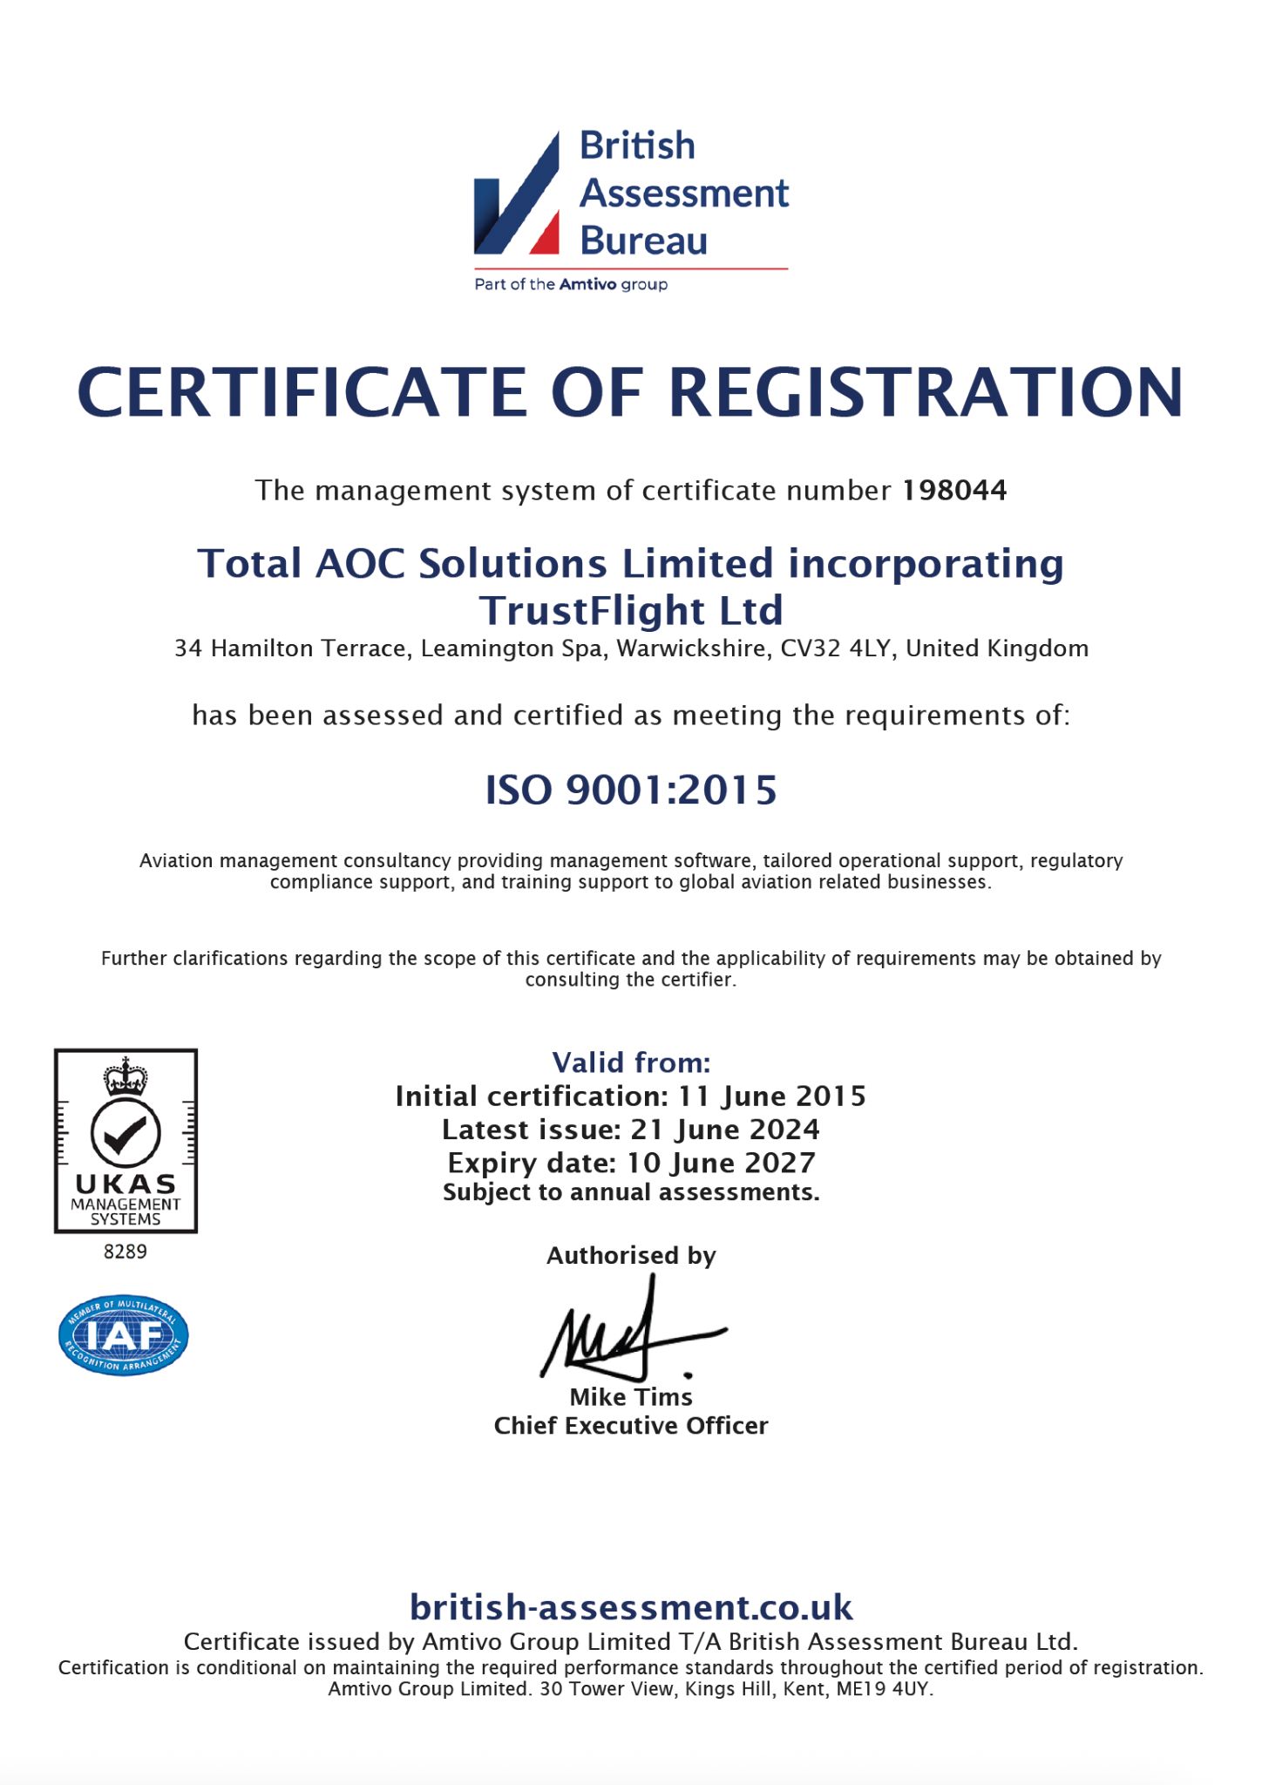

ISO 27001 Certification
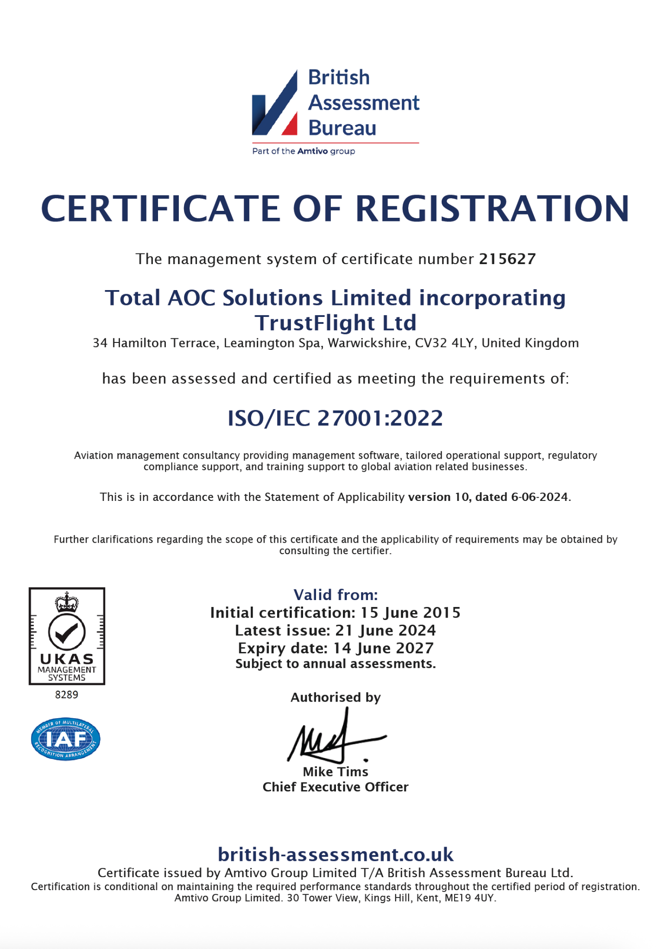


TrustFlight United Kingdom | TrustFlight North America | TrustFlight Jersey
UK +44 (0) 330 229 0219 | US +1 (844) 784 9836 | UK +44 (0) 330 229 0219
London  22 Lavington Street  London, SE1 0NZ  Bracknell  The Western Centre  Bracknell, Berkshire, RG12 1RW  Doncaster  The National Safety & Security Academy, First Avenue  Finningley, Doncaster, DN9 3RH  Luton  Basepoint, Great Marlings  Luton, Bedfordshire, LU2 8DL | Vancouver  Commerce Place, 1110 – 400 Burrard St  Vancouver, BC, V6C 3A6  Houston  2408 Timberloch Place, Suite A5  The Woodlands, TX 77380 | Jersey  Ground Floor, Forum 4, Block 3  Grenville Street, St Helier, JE2 4UF  Jersey, Channel Islands
sales@trustflight.com | trustflight.com

